1.Data Model relating Trips with Master Data:
1. Fix missing fuel consumption values :
No missing values in the Dataset.
2. Relate Trips with Vehicle Master.

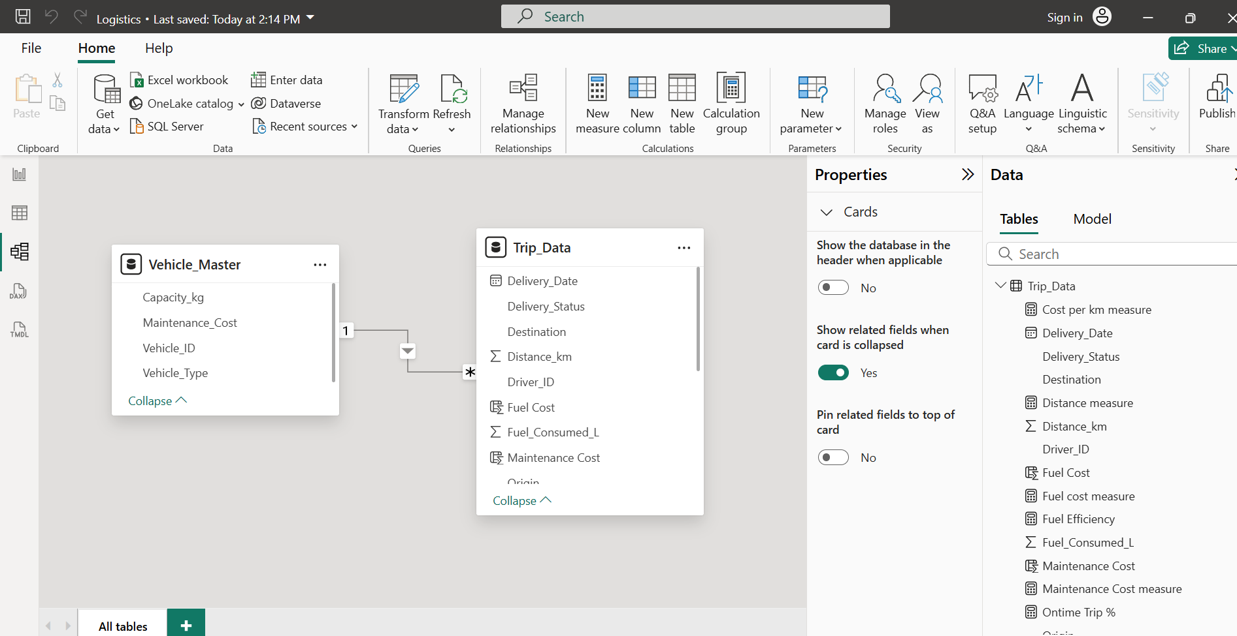

2. DAX Measure:
Fuel Efficiency = Distance / Fuel Consumed
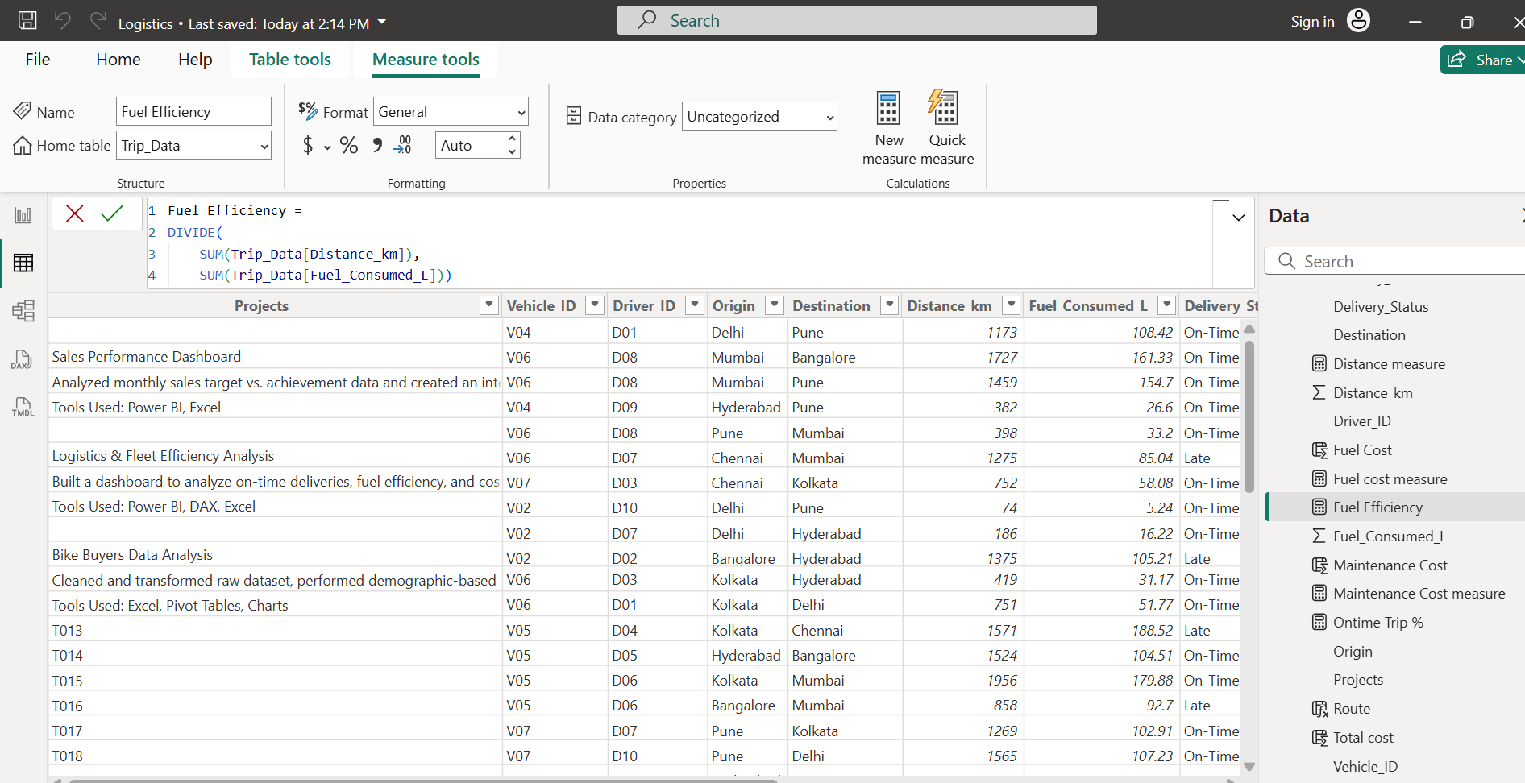
2. On-Time Delivery % = On-Time Trips / Total Trips

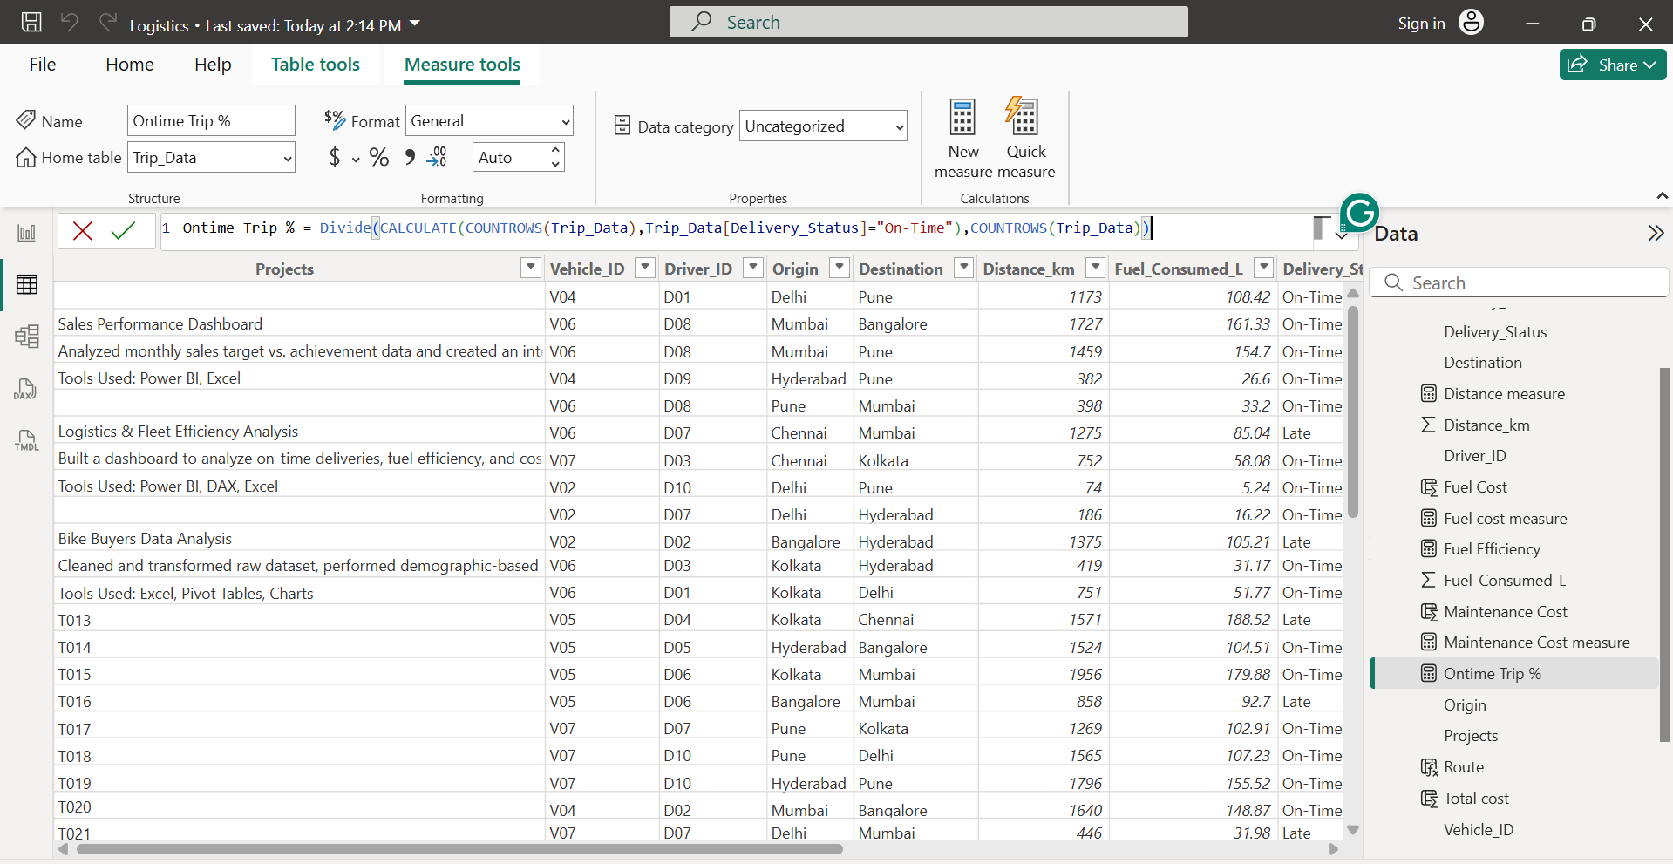
3. Cost per km = (Fuel Cost + Maintenance Cost) / Distance
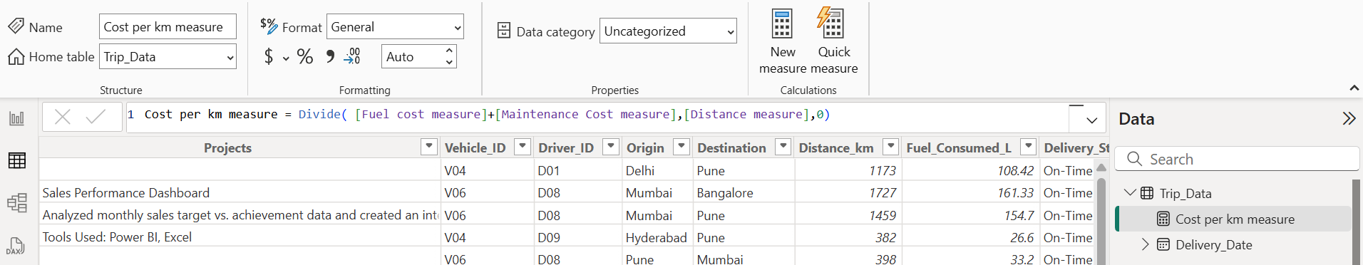

3. Visualization:
1. Bar chart: On-Time Delivery % by Route.
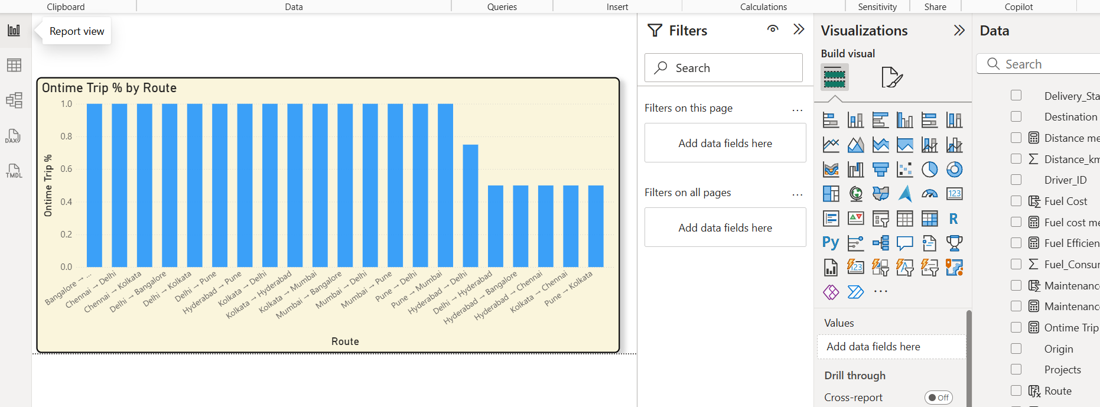

2. Line chart: Fuel Efficiency trend by month.
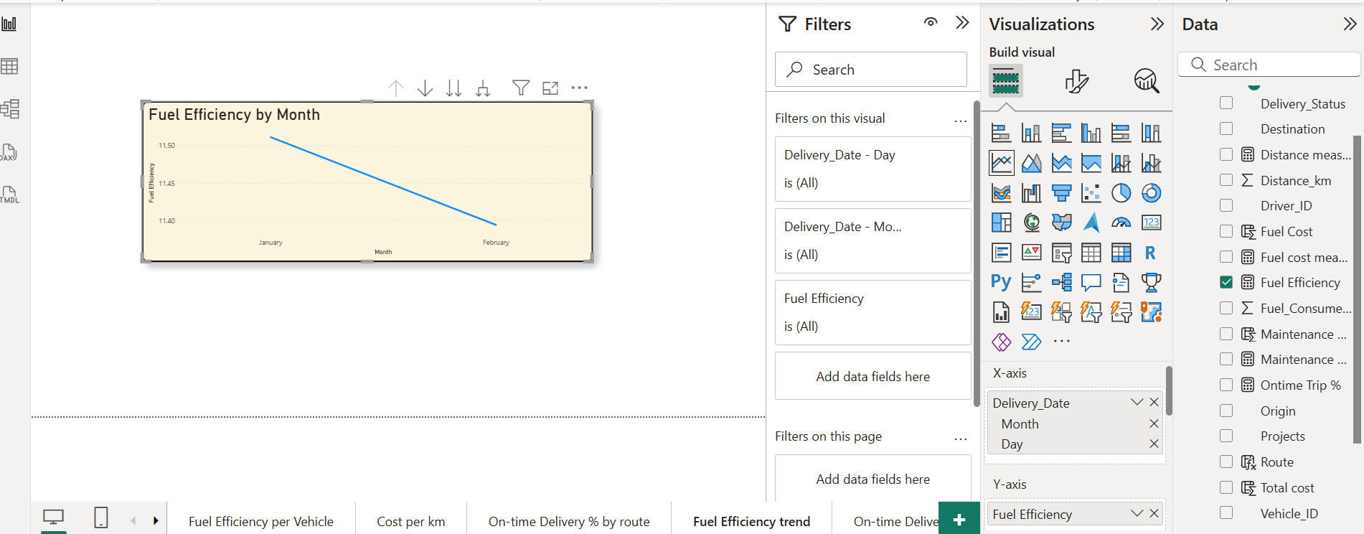

3. KPI cards: Avg. Delivery Time, Cost per km.
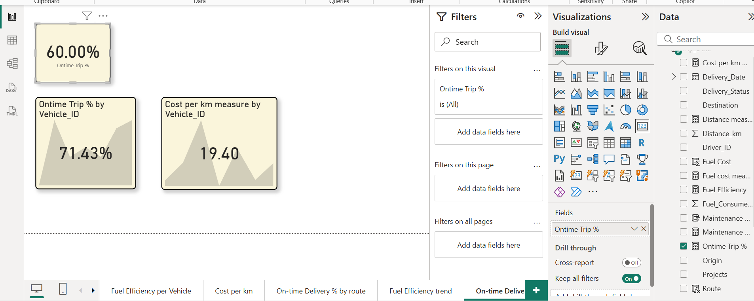

4. Map visual: Delivery performance by route (Origin → Destination).
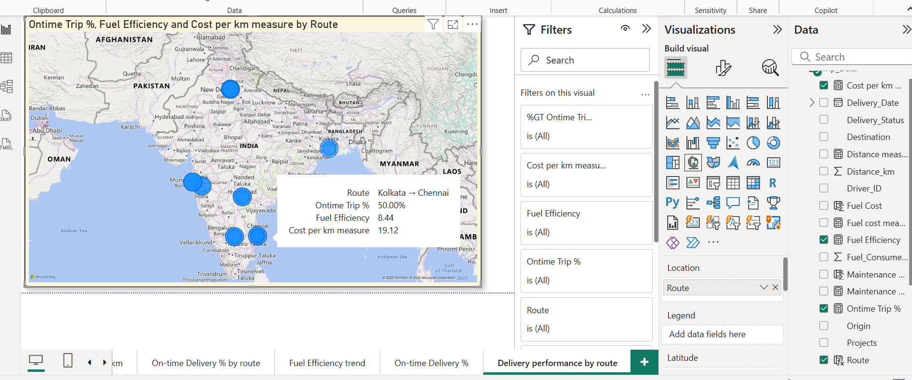
Dashboard:
